Citizen Grievance & Sentiment Analysis System
SUBMITTED BY UVESH SHAIKH

Week 1 Report: Data Collection, Cleaning and Exploratory Data Analysis

1. Introduction

The objective of this project is to develop an AI-based system for analyzing citizen complaints in the government and public sector. The system aims to automatically categorize complaints and analyze their sentiment to improve grievance redressal.

2. Data Collection and Understanding

The dataset contains structured information about citizen complaints collected from public service records, including details such as complaint type, description, location, and status. These attributes help in understanding the nature of public issues.

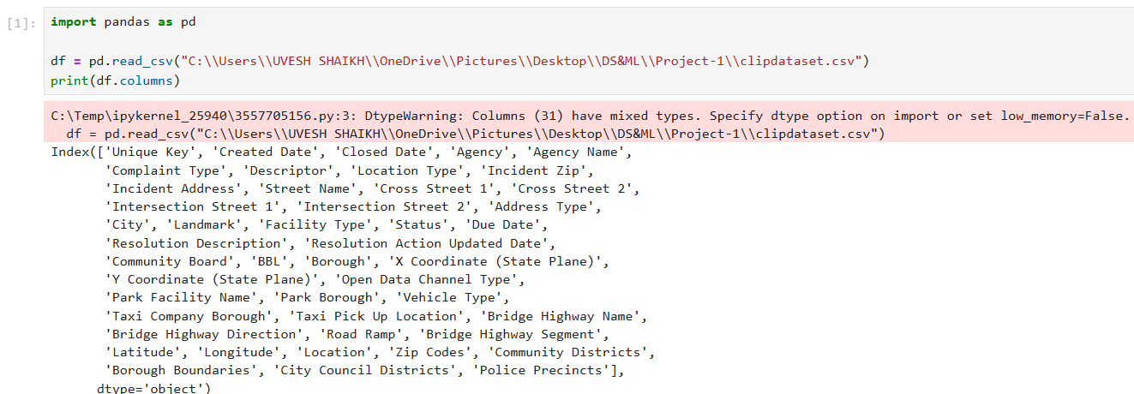

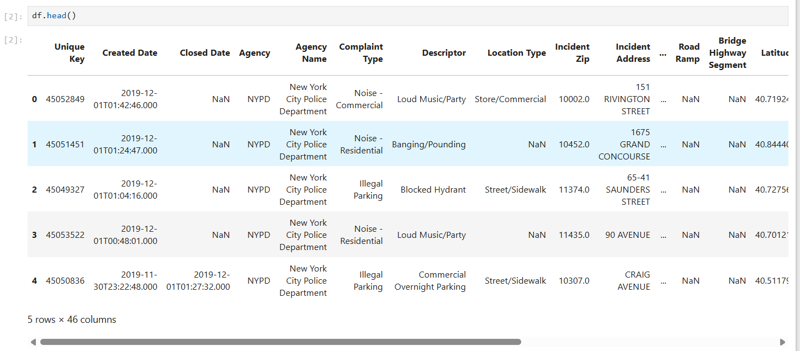

2.1 Data Information

The dataset consists of multiple columns representing different aspects of complaints. Important features include:
- Complaint Type: Type/category of complaint
- Descriptor: Detailed description of the issue
- City: Location of the complaint
- Status: Current state of complaint resolution
- Created Date and Closed Date: Timeline information
The dataset contains both categorical and numerical data. Some columns have missing values, especially in descriptive fields, which were handled during preprocessing.
Source Code:
df.info()
df.shape
df.isnull().sum()

3. Data Preprocessing (Text Cleaning)

Since the dataset does not contain a single text column, a new column named “text” was created by combining the “Complaint Type” and “Descriptor” columns.
Source Code:
df['text'] = df['Complaint Type'].fillna('') + " " + df['Descriptor'].fillna('')
Text cleaning was performed to make the data suitable for analysis. The following steps were applied:
- Converted text to lowercase
- Removed special characters and numbers
- Removed stopwords such as “is”, “the”, and “and”

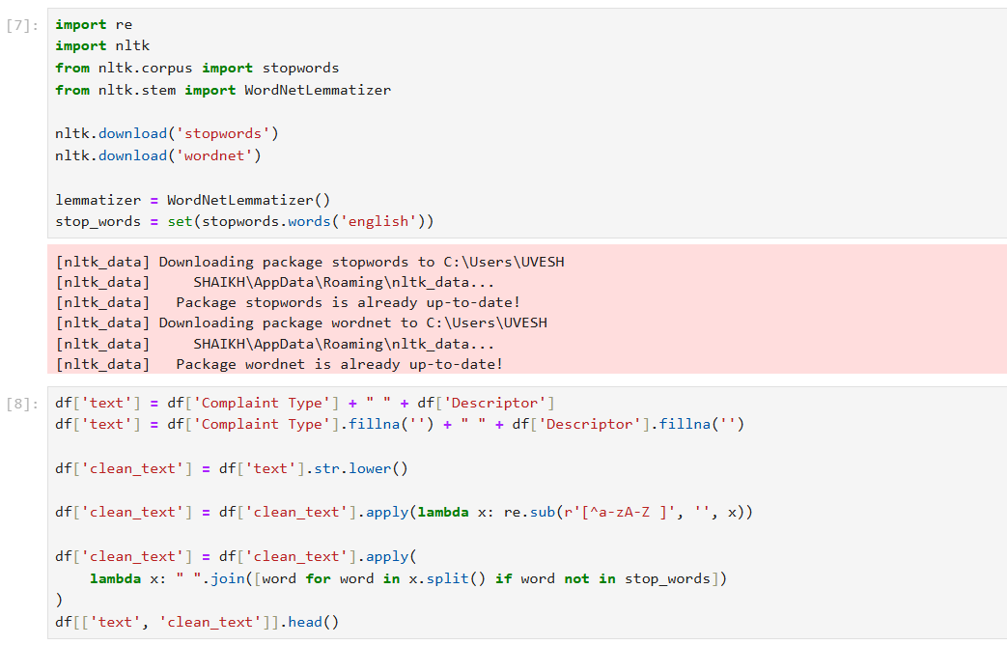

Source Code:
import re
from nltk.corpus import stopwords

stop_words = set(stopwords.words('english'))

df['clean_text'] = df['text'].str.lower()

df['clean_text'] = df['clean_text'].apply(lambda x: re.sub(r'[^a-zA-Z ]', '', x))

df['clean_text'] = df['clean_text'].apply(
lambda x: " ".join([word for word in x.split() if word not in stop_words])
)

df[['text', 'clean_text']].head()

4. Exploratory Data Analysis (EDA)
EDA was conducted to identify patterns and trends in the complaint data.

4.1 WordCloud Visualization
A WordCloud was generated to visualize the most frequent words in the dataset. Words appearing larger indicate higher frequency.

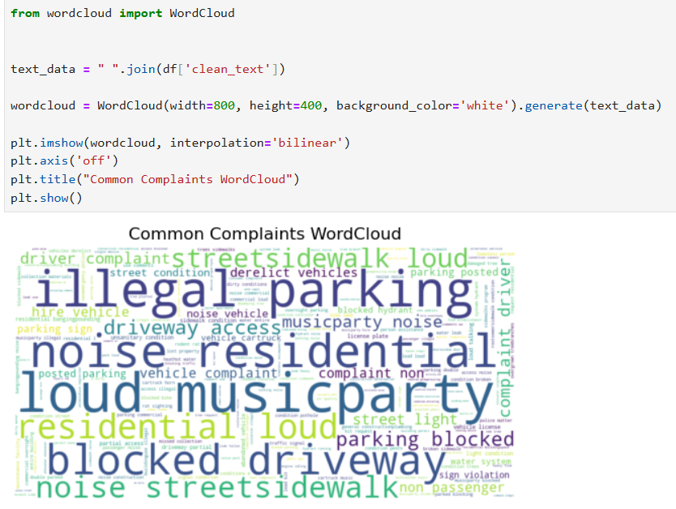

The WordCloud shows frequently occurring terms such as “noise”, “water”, and “street”, indicating major urban issues. The bar graph highlights the most common complaint categories, helping identify priority areas for government action.

4.2 Complaint Type Distribution

The bar graph clearly shows the most frequent complaint types, helping identify major areas that require government attention.

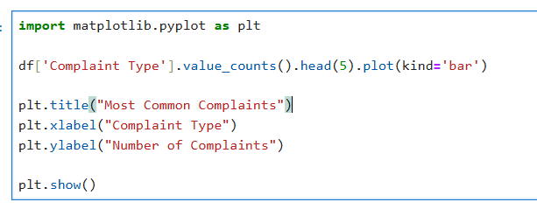

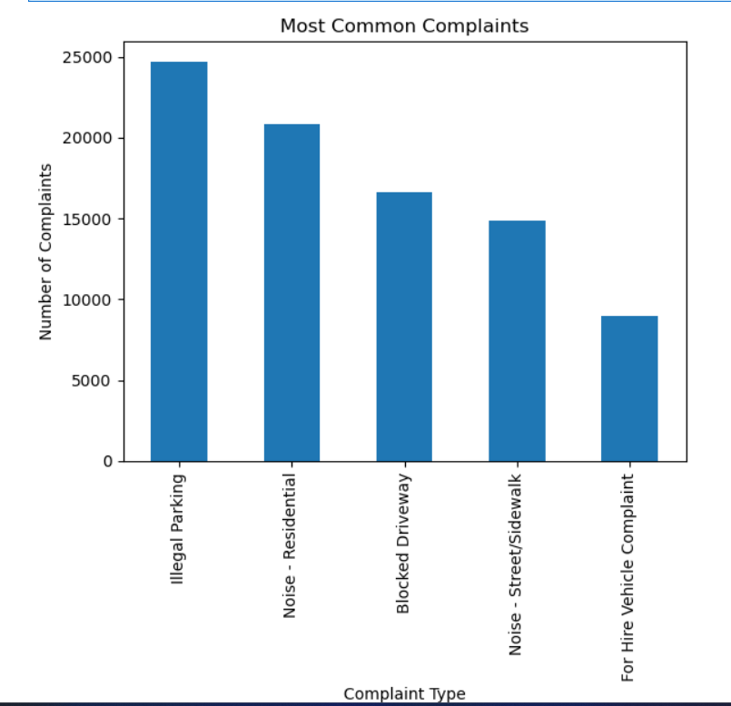

5. Key Insights

- Most complaints are related to urban infrastructure and public issues
- Common issues include noise, water supply, and street-related problems
- Text preprocessing improves the quality of data for further analysis
- Visualization techniques help in identifying major complaint trends

6. Conclusion

In Week 1, the dataset was successfully analyzed and prepared for further processing. Text preprocessing techniques were applied to clean the data, and exploratory data analysis was performed to understand complaint patterns. Visualizations such as WordCloud and bar charts provided meaningful insights into common public issues. This work forms the foundation for building machine learning models for complaint classification and sentiment analysis in the upcoming weeks.

